Data Mining Lab 4
Muhammad Hassan Khalid
21L-5692

Data loading and analysis
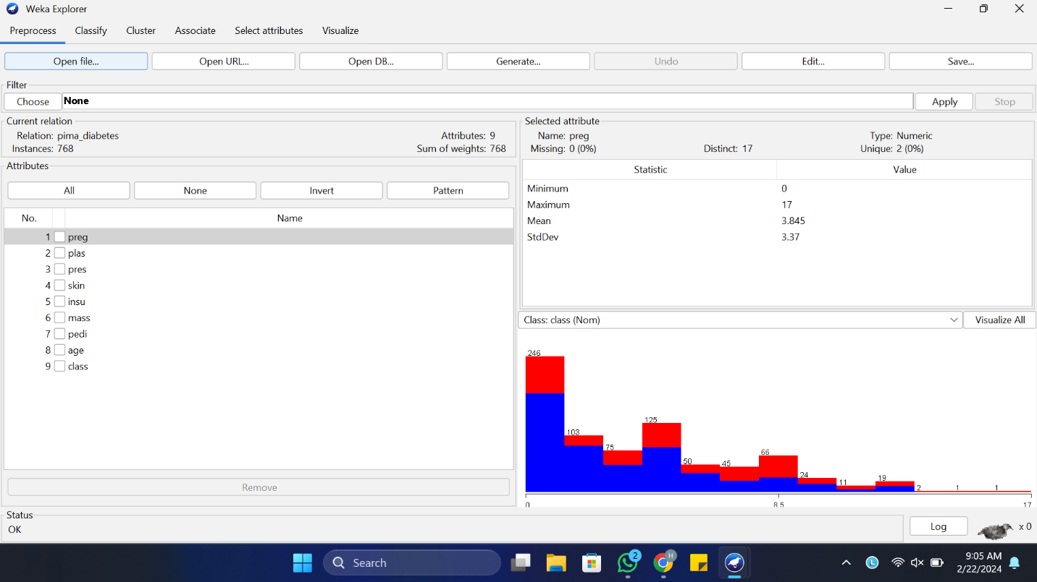

- What is the size of the training set?
The size of the training set is 768.
- How many attributes exist in the training set?
A total of 9 attributes exists among which 8 are the independent variables and 1 is the target or class or dependent variable which needs to be predicted.
c) How many instances are positive (Enjoy = yes) and how many negative?
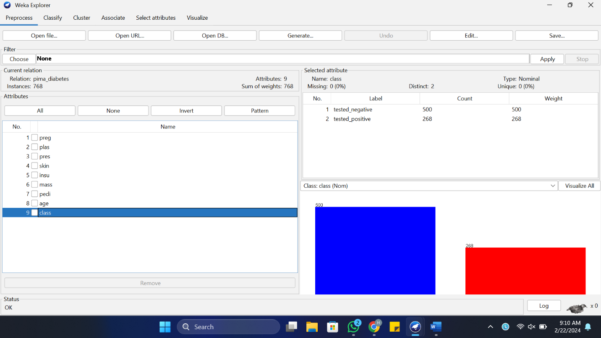

There are 500 negatives instances and 268 positive instances.
d) Which attribute best separates the data?
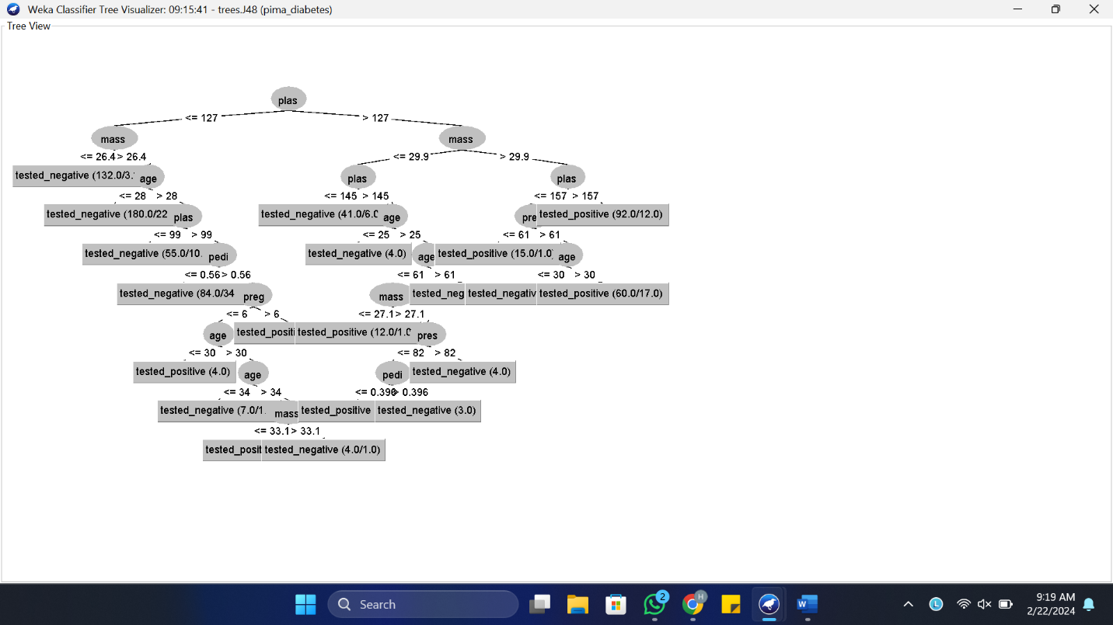
The attribute plas best separates the data.
e) How many elements from the data set have the humidity attribute set as high?
Not applicable on our dataset.

Load and analyse data
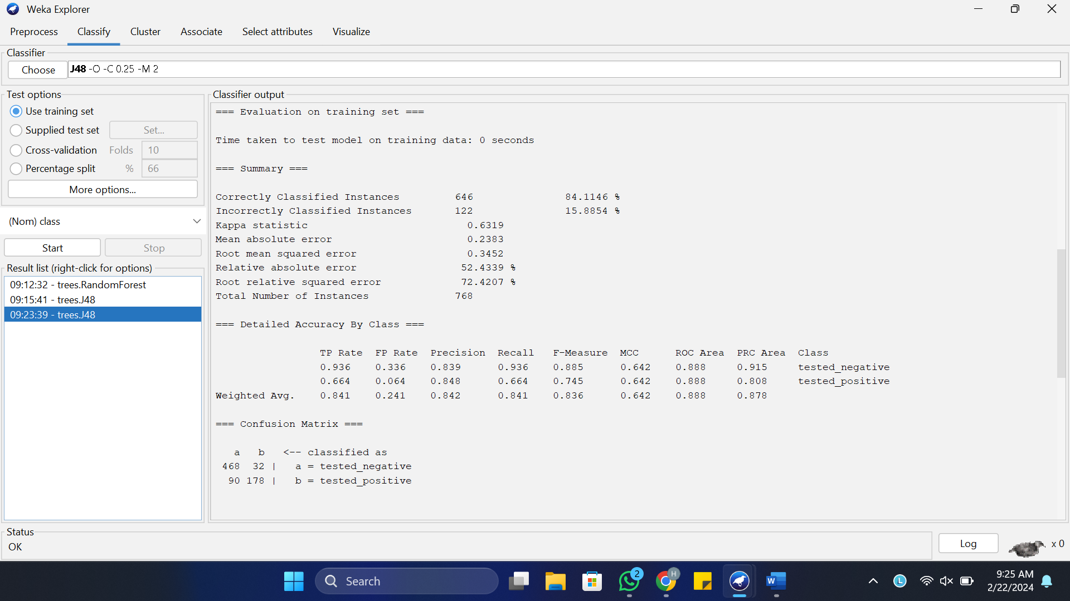
The results tell us that the classifier has Correctly Classified Instances 646 that is a percentage of 84.1146 % and Incorrectly Classified Instances are 122 that is a percentage of 15.8854 % which means it has done a satisfactory job on training the model.

III. Classification accuracy
4. Run the algorithm. How many percent of cases were correctly classified? Is this a good result?
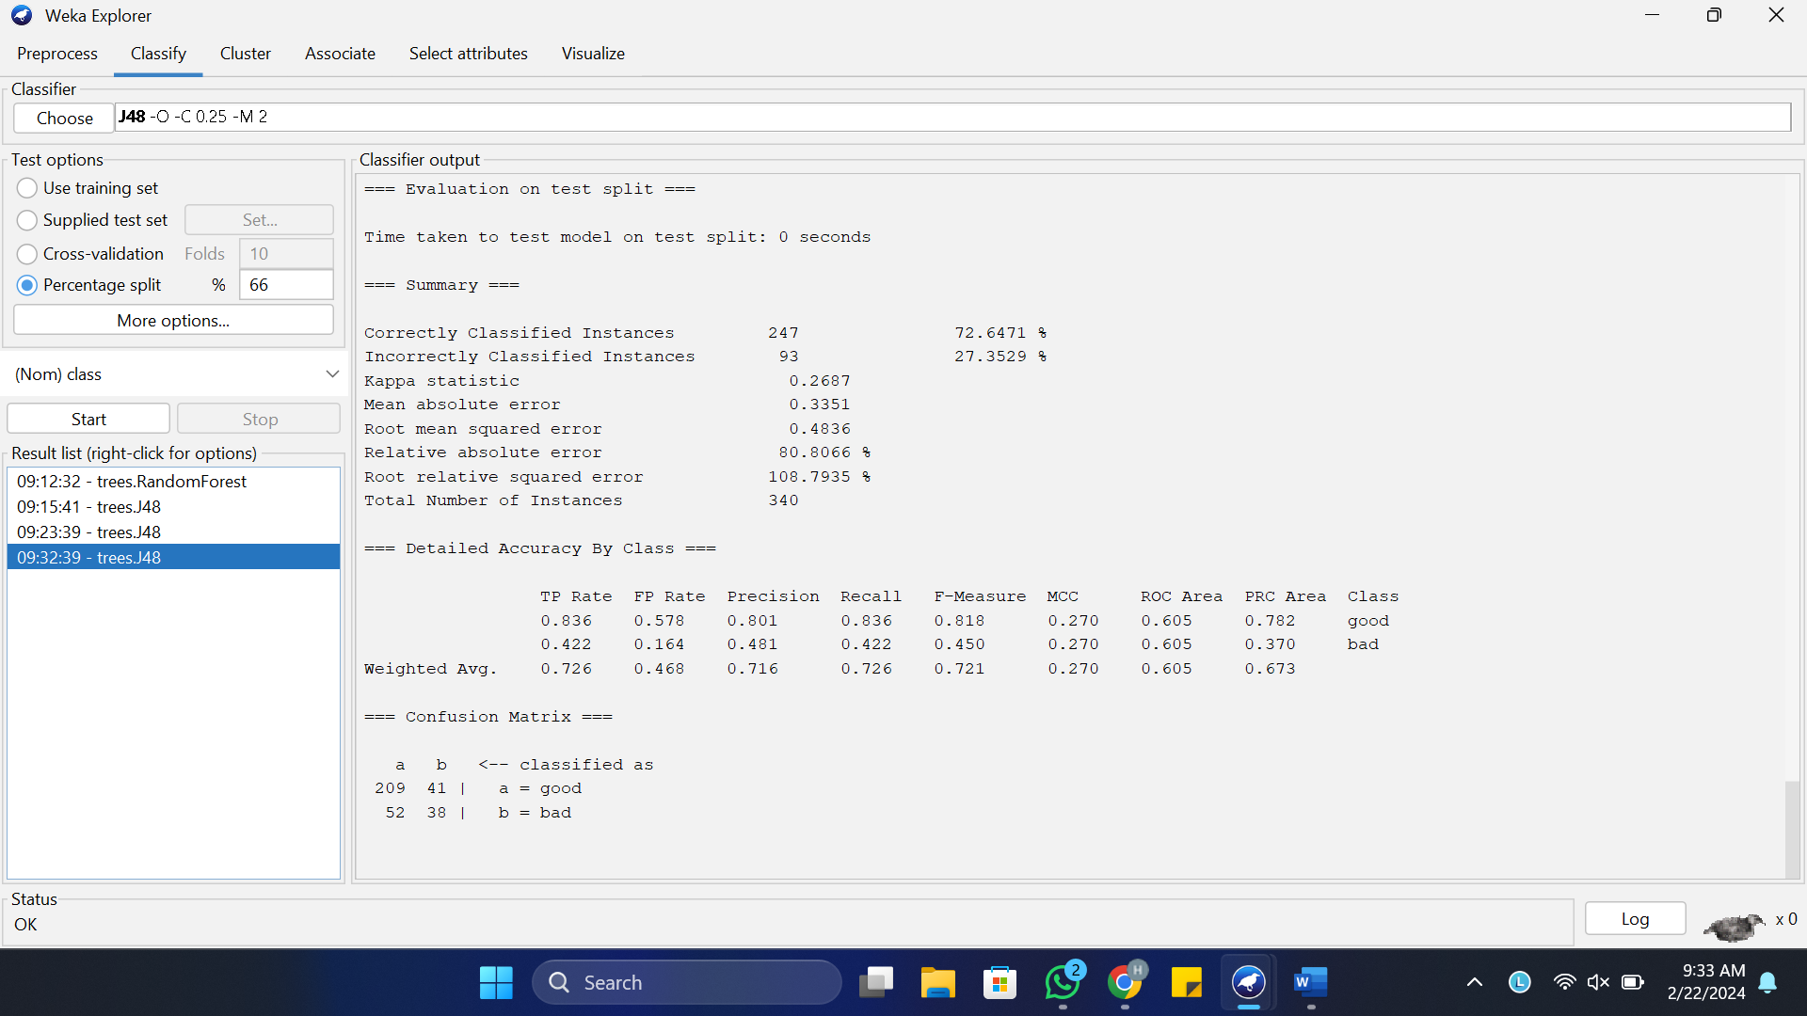

The results tell us that the classifier has Correctly Classified Instances 247 that is a percentage of 72.647 % and Incorrectly Classified Instances are 93 that is a percentage of 27.3529 % which means it has not done a good job on training the model and there is need for improvement.

5. Change the classifier to ZeroR from the rules branch. What is the obtained result? Better or worse than J48?
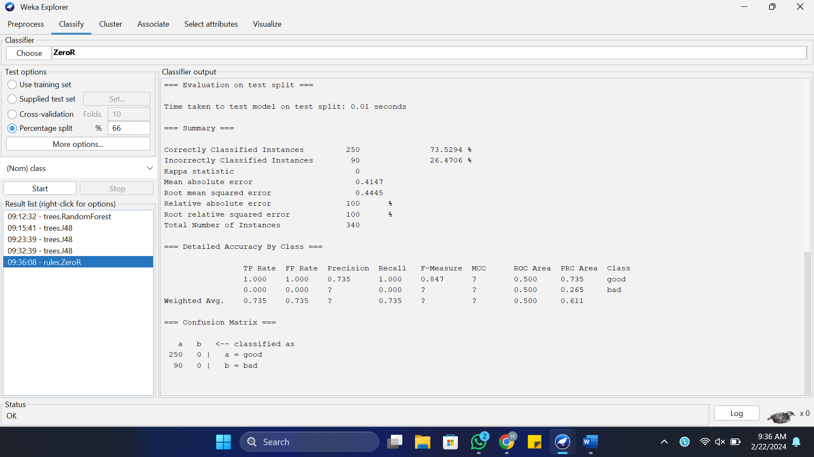

The results are same and still needs a lot of improvement.
6. Try other classifiers. What are their results?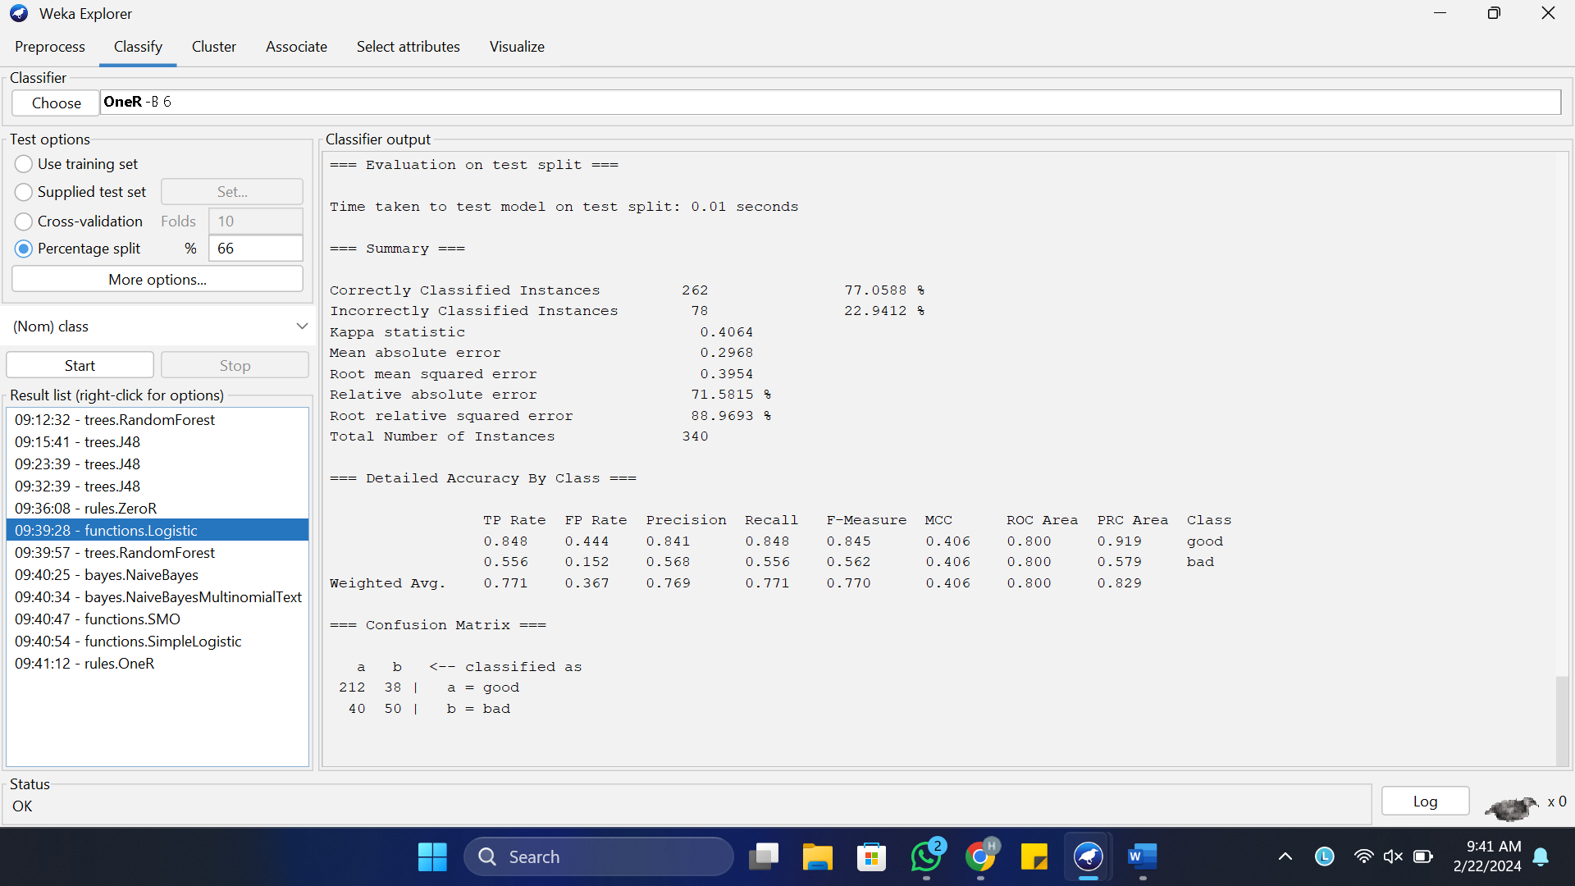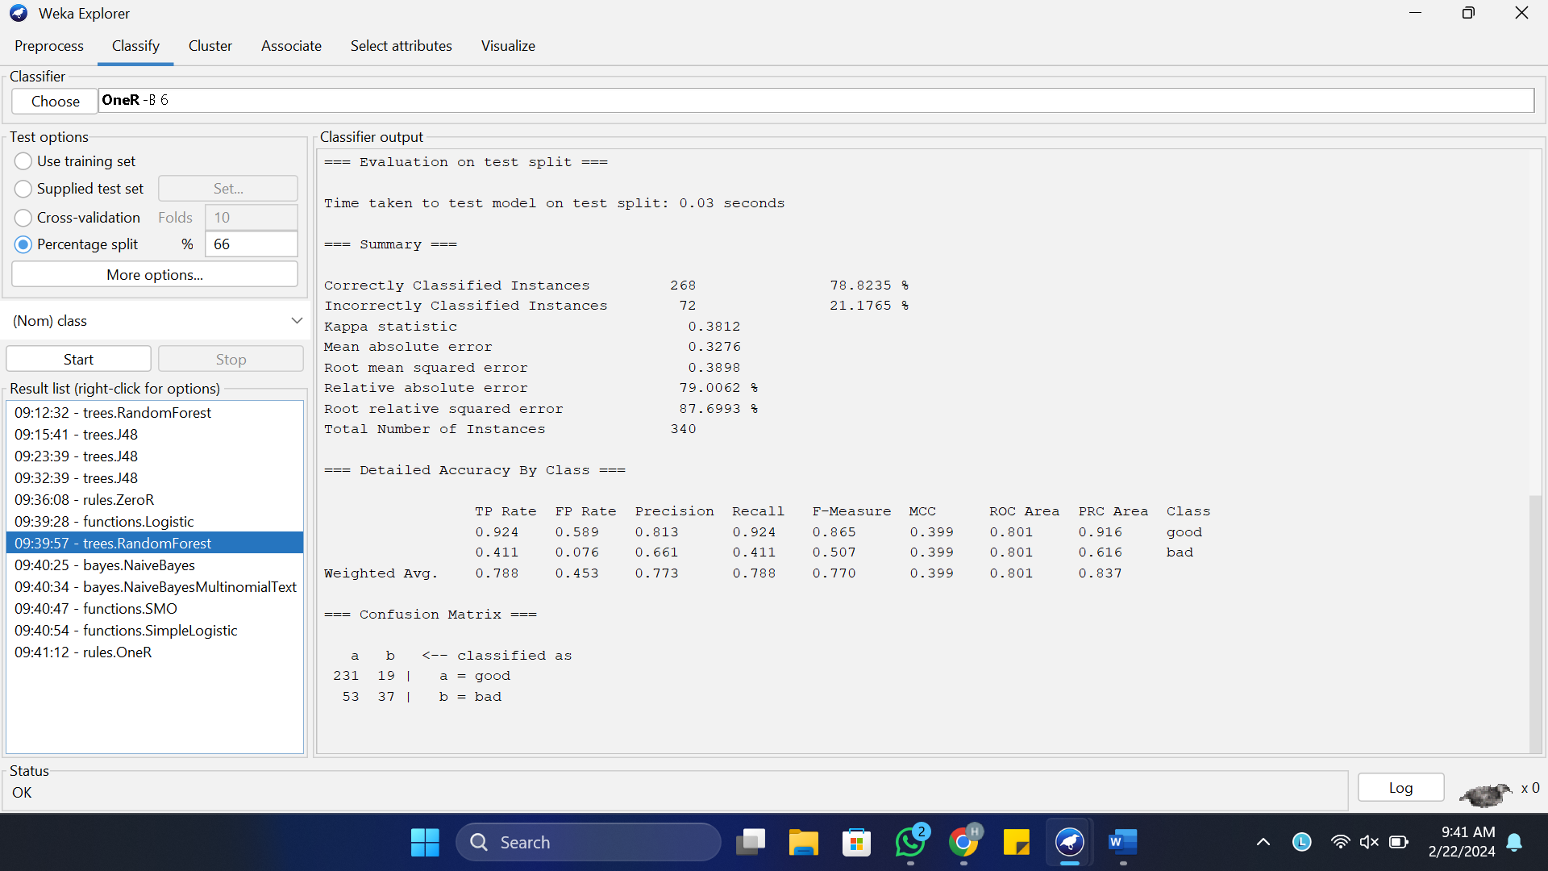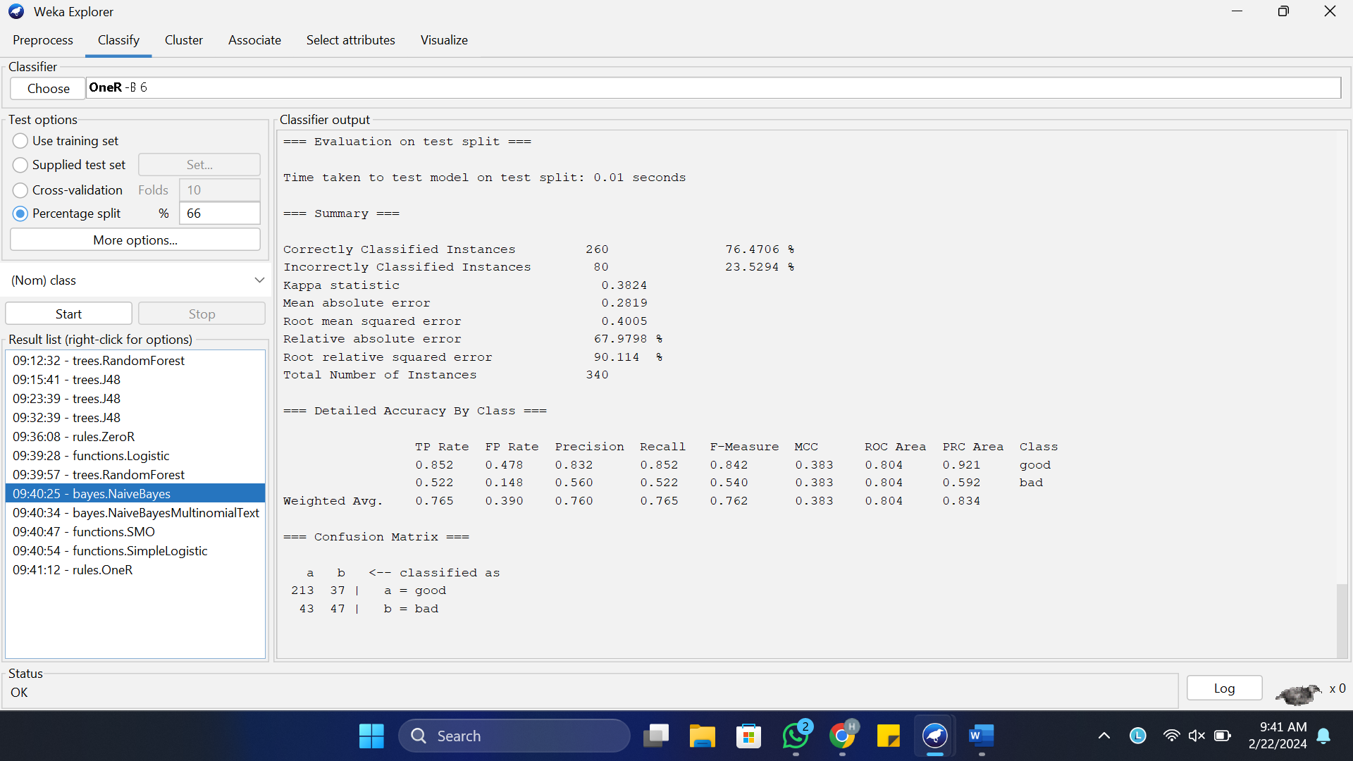
7. Go to the ‘Preprocess’ tab and see how the distribution of the attribute defines whether the set is good or bad. What would be the effectiveness of an algorithm that regardless of the value of attributes would "shoot" that the user is reliable or not?
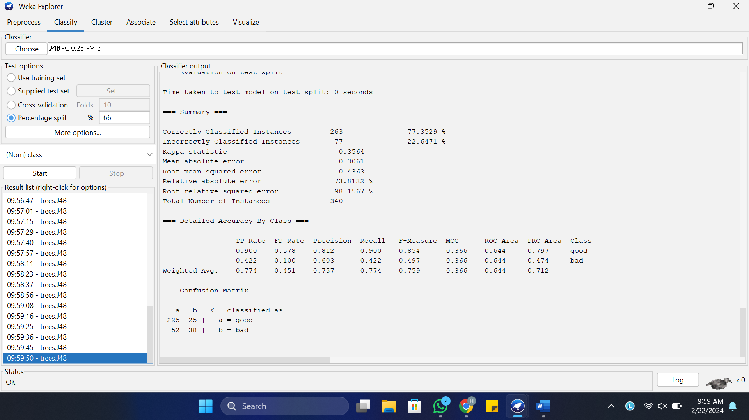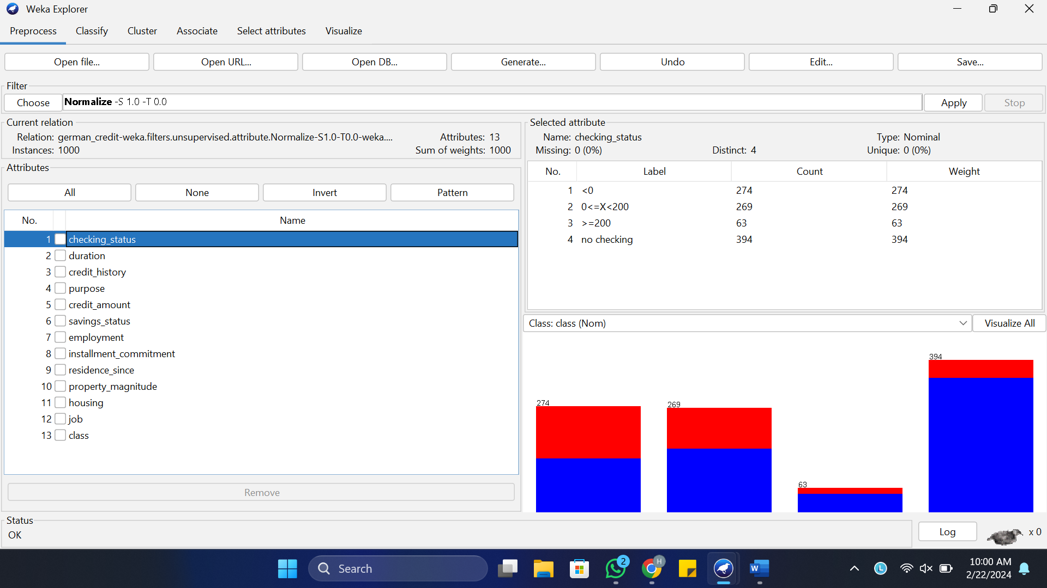
8. Why is it worth taking a look at the data before attempting a classification task?
Just by looking at the data and doing a little preprocessing by removing unwanted attributes and normalizing I was able to increase my model’s performance by up to 5 percent. In the personal_status attribute the number of male and female singles are to the extreme opposites due to which it needs to be removed also in other parties the none is dominating and ruining the model. The age attribute is also right-skewed hence that needs to be removed too also all the numeric attributes are of varying values that is proving a challenge for our classifier hence we normalized all the features except the class attribute.

Naïve Bayes classifier
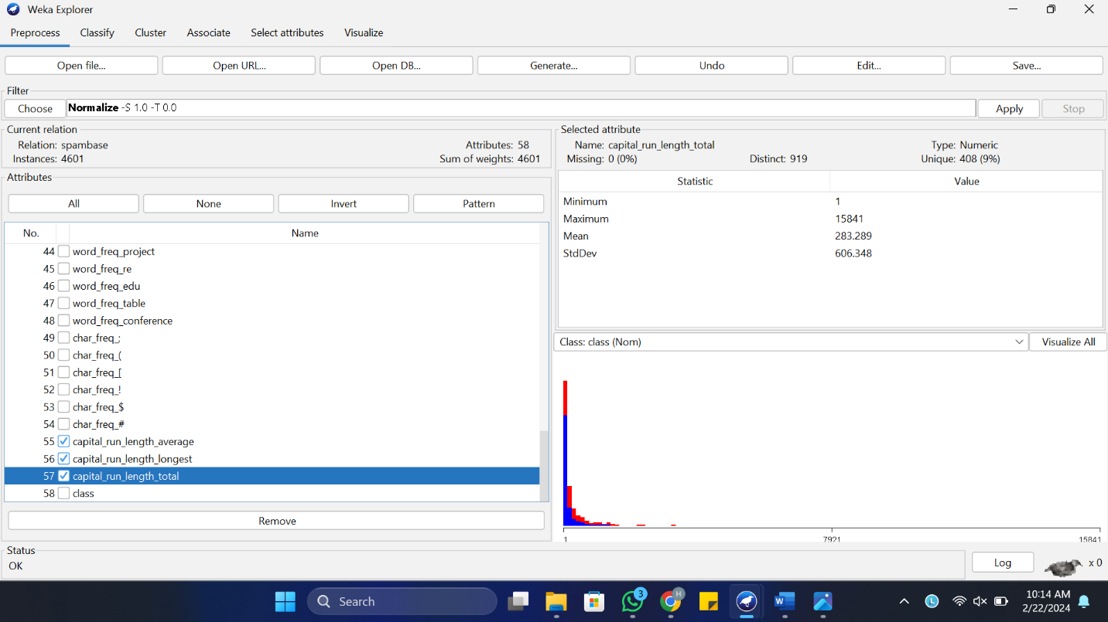

2. Leave the default settings and hit Start to build the classifier. Study the output produced, most importantly the percentages of correctly and incorrectly classified instances. You probably will notice that your classifer does rather well despite making a very strong assumption on the form of the data.
o Can you come up with a reason for the good performance? What would be the main practical problems we would face if we were not to make this assumption for this particular dataset?
o How long did your classifer take to train and classify? Given this, how scalable do you think the Naïve Bayes classifier is to large datasets? Can you come up with a good reason for this?
The Naïve Bayes classifier works well because it assumes that features are independent given the class. This helps it to handle noise and simplifies calculations.
Without this assumption, dealing with many features becomes difficult, leading to overfitting or slow computations.
The classifier is fast to train and classify, taking only 0.05 seconds in this case. It's good for big datasets because it's simple, doesn't need much memory, and works quickly even with many features.

3. Examine the classifier models produced by Weka (printed above the performance summary). Find the prior probabilities for each class.
o How does Naïve Bayes compute the probability of an e-mail belonging to a class (spam/not spam)?
o Compute the conditional probability of observing the word "3d" given that an e-mail is spam P(3d|spam) and that it is non-spam P(3d|non-spam). To do this, we need to use the counts of the built model that are produced within the Classifier output screen under the Classify tab. The general format of the Weka count output is (Note: this is a toy example. You will need to examine your Weka output to find the true counts for the word "3d".):

The counts for each class are as follows:
Class 0 (not spam): Total instances = 2790
Class 1 (spam): Total instances = 1815
To compute the prior probabilities, we divide the number of instances for each class by the total number of instances:
Prior probability of class 0 (not spam) = 2790 / (2790 + 1815) ≈ 0.605
Prior probability of class 1 (spam) = 1815 / (2790 + 1815) ≈ 0.395
So, the prior probabilities for class 0 (not spam) and class 1 (spam) are approximately 0.605 and 0.395, respectively.
The conditional probabilities of observing the word "3d" given that an email is spam (P(3d|spam)) and given that it is non-spam (P(3d|non-spam)).
From the output provided:
For spam (Class 1):
Count of instances where word_freq_3d_binarized = 1 and class = 1: 40
For non-spam (Class 0):
Count of instances where word_freq_3d_binarized = 1 and class = 0: 9
To compute the conditional probabilities, we divide the count of instances where the word "3d" appears in emails of each class by the total number of instances in that class:
P(3d|spam) = Count of instances where word_freq_3d_binarized = 1 and class = 1 / Total instances of spam = 40 / 1815 ≈ 0.022
P(3d|non-spam) = Count of instances where word_freq_3d_binarized = 1 and class = 0 / Total instances of non-spam = 9 / 2790 ≈ 0.003
So, the conditional probability of observing the word "3d" given that an email is spam (P(3d|spam)) is approximately 0.022, and given that it is non-spam (P(3d|non-spam)) is approximately 0.003.
4. For the final part of this section we will now pretend we are spammers wishing to fool a spam checking system based on Naïve Bayes into classifying a spam e-mail as ham (i.e. a valid e-mail). We will now use all of the training data to train our classifier and apply the learnt classifer to a dedicated test set. Load the test set in Weka. Under the Classify tab, select supplied test set > set > open file and set the test file to the supplied spambase_test.arff. This ARFF file contains the binary vector representing one spam e-mail. Run the Naïve Bayes classifer on this test set. Does the classifer classify the spam e-mail correctly?

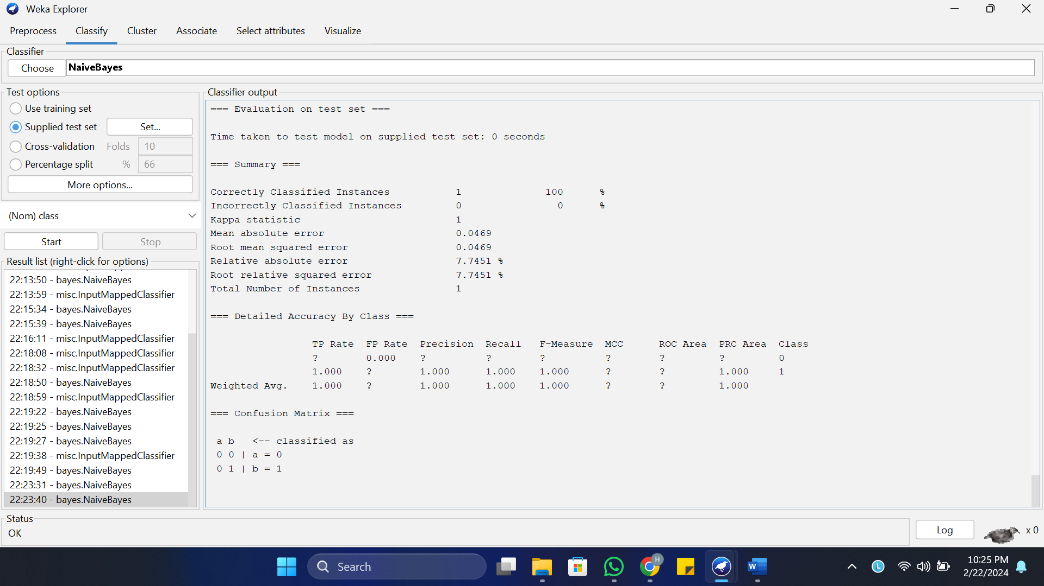

The Naive Bayes classifier achieved perfect accuracy on the test set, correctly classifying all instances. Therefore, the spam email was classified correctly as spam, not ham.
5. Open the test file spambase_test.arff in emacs or another text editor. Identify good non-spam words and add these to the e-mail. Important: Leave the class label (last attribute value) in the test data file untouched. During testing, Weka will ignore this attribute and will instead use our previously trained classifier to predict the class label of this e-mail. Re-run the classifer on the modified test set. Has the class label (spam/non-spam) for this e-mail changed?

To simulate adding good non-spam words to the email, words from the attributes that have a higher frequency in non-spam emails:
- word_freq_people_binarized
- word_freq_report_binarized
- word_freq_technology_binarized
Adding these words to the email and keep the class label unchanged:

0,1,1,0,1,0,0,0,0,0,0,1,1,1,0,1,0,1,1,0,1,0,0,0,0,0,0,0,0,0,0,0,1,0,0,0,0,0,1,0,0,0,0,0,0,0,0,0,0,0,0,1,0,0,1
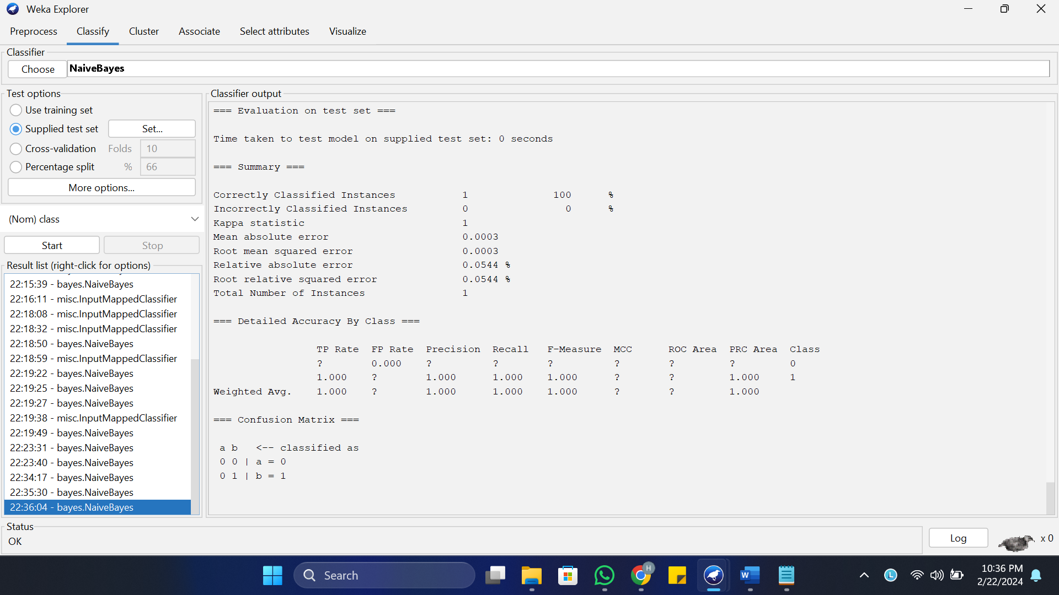

The classifier still correctly classified the email as spam even after adding good non-spam words. Therefore, the class label for the email remains unchanged as spam.

